Assignment 01

Parth Chandgadhiya 300986134

Find Errors

1. Double Done
2. Gooogle Search spelling is incorrect
3. Untitled tab is missing parenthesis
4. Feeling unlucky
5. Close
6. No loading signs
7. Lanuage Spelling is wrong
8. More is no Capitalized
9. Scroll bar has two repetitive dashes.
10. News is not aligned
11. Igoogle is not a valid option
12. Two Down Arrow
13. Two Down Arrow
14. Two Words starting with H
15. More arrow is upward
16. Google O is not having shadow
17. Maximize button is wrong
18. Shortcut error
19. Loading logo is Still there
20. Two || Lines
21. Hopping instead of shopping

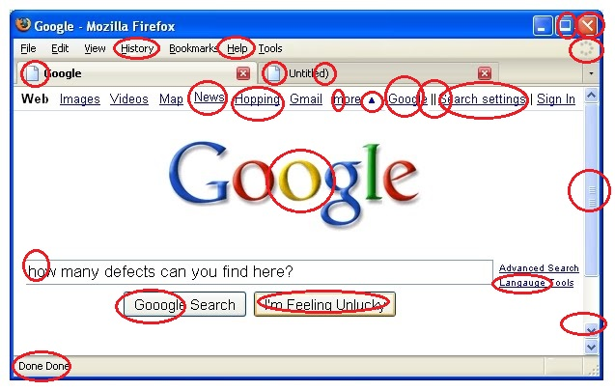

Bugs based on Requirements

**1.) Email Address**

Category: [Missing]

ABC Customer wanted had requested for Email Address in business card, while deliverable is devoid of Email Address.

**2.) Color**

Category: [Incorrect]

ABC Customer received a business card with pinkish red color, while the Requirement was Pink.

**3.) Company’s tagline**

Category: [Extra]

ABC Customer never asked XYZ for including their company’s tagline into business card.

**4.) Employee’s department**

Category: [Extra]

XYZ mentioned about the employee’s department even though that was not in ABC’s requirement.